Year 2
Please find todays learning tasks below.
The table below explains the tasks and you will find the resources underneath.
Your child will know which challenge they usually access in each subject and which task will be appropriate for them.
Year group: 2 Date: 03.07.20
English | 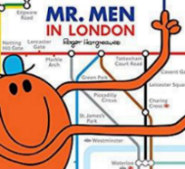  Reread the story of the Mr Men in London.
 | Challenge 1 | Challenge 2 | Challenge 3
Reread the story you wrote yesterday to remind you about where you are up to.
Today you are going to be retelling the final parts of the story in your own words – look at the pictures on the activity sheet (below) and think about what happens in the story from each picture.

Retell the story and try and think about some of these to include as you write.
- Capital letters, finger spaces and full stops throughout.
- Speech “ “ if characters are speaking.
- Start your sentences in different ways you could use time connectives, exciting words etc.
- Remember to use capital letters for character names and places too!
- Reread your writing to make sure it makes sense
Maths | 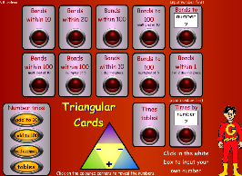  Complete the interactive ‘Number bonds within 100 – Multiples of 5’ activity on the following link:  http://www.wldps.com/gordons/Triangular_cards.swf
 | Challenge 1 | Challenge 2 | Challenge 3
Today you need to complete the activity sheet following instructions on the treasure map and showing you understand about clockwise and anti-clockwise.

Don’t forget to complete your reasoning task.
Reading  Phonics | Complete the reading activity sheet below.  Share the link and activity on:  https://www.roythezebra.com/reading-games/high-frequency-words-days.html
Other | Today we are going to complete PE (Dance)  Great Fire of London Dance using the link below.  https://www.bbc.co.uk/teach/school-radio/history-great-fire-of-london-samuel-pepys-part-1/zrkdcqt

Unless otherwise specified, please complete the tasks in either your home learning book or print out the document below.

English All challenges

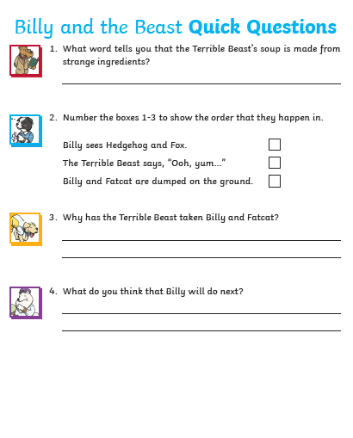
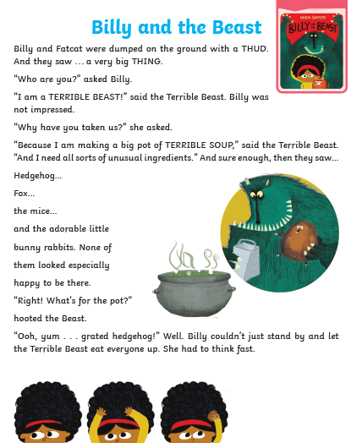
Reading Task
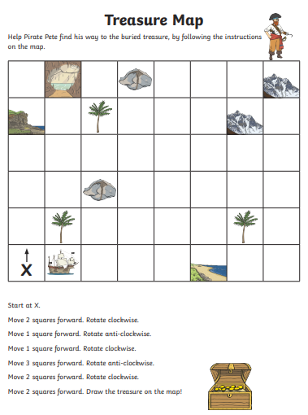
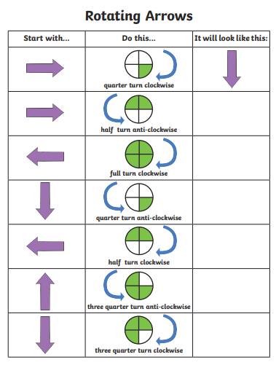
Maths ALL challenges
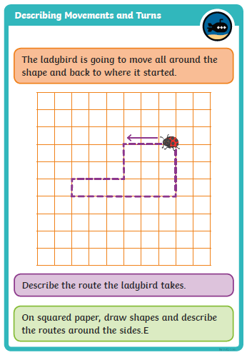
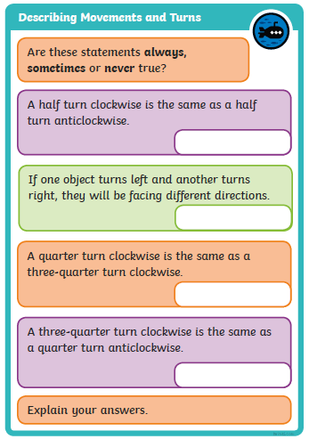
Reasoning ALL challenges

