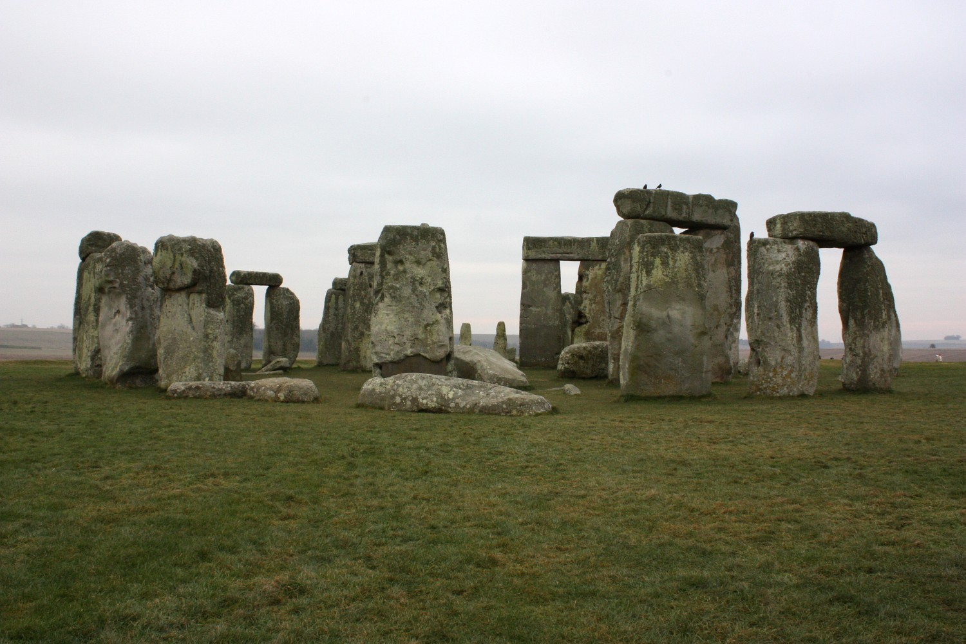

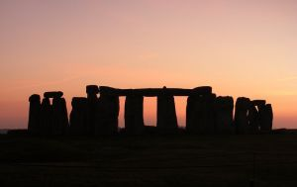
Year: 3
Term: Autumn 1
Topic: Stone Age
Special Events:
Trip to Macclesfield Forest
Parent Engagement Forest School

RE/PSHRE
We will learn that there are different kinds of responsibilities, rights and duties at home, at school, in the community and towards the environment.
We will research, discuss and debate topical issues, problems and events concerning the environment and offer our recommendations.
We will understand school rules about health and safety, basic emergency aid procedures and where and how to get help.
We will develop strategies for keeping physical and emotionally safe –including online safety
We will reflect on and celebrate our achievements, identify our strengths and areas for improvement, and set high aspirations and goals
We will understand the concept of ‘keeping something confidential or secret’, when we should or should not agree to this and when it is right to ‘break confidence’ or ‘share a secret’.
Debate – Should women have been allowed to hunt?

History/Geography
- We will learn to compare events from the past to the current day.
-We will place main events on a time line placing them in chronological order.
-We will study a specific place (Skara Brae)
-We will learn about the life style of an early Brit. (communicate, eat and live)

English
Narrative – Stone Age boy – To write our own stone age story focusing on fronted adverbials
Diary Entry – Diary of a Killer Cat - Focusing on features and applying them.
Riddles
Maths
Number and Place Value – using numbers to 1000, reading and writing in numerals and word, partitioning numbers into tens and ones.
Addition and Subtraction – calculating using one and two digit numbers and key vocab.

Computing
- We will learn the importance of keeping our personal information private and how to be safe on the internet.
- We will be able to use search engines safely to locate information.
- We will learn basic computer skills such as saving, opening and printing our.
- We will present our understanding of the Stone age through digital and printed media, such as Microsoft PowerPoint.

Science
- We will compare and group different types of rocks based on their appearance and physical properties.
- We will describe how fossils are formed.
- We will learn to recognise that soils are made from rocks and organic matter.
Investigation- How do we separate rocks from soils?

PE- Gymnastics
-We will develop jumps, balances, travel and shapes, improving flexibility and control
- We will perform these aspects of PE on the floor and on equipment.
- We will compare these performances to one another, giving feedback to help us to achieve personal bests.

Art/Design
- We will develop our sketching and pencil skills.
- We will use these techniques to create our own paleolithic inspired art.
- We will use a range of materials to create a collage based on Stonehenge
-We will design, make and evaluate our own Stone Age hunting tools.

Music
- We will develop our understanding of rhythm and pitch and how these impact a piece of music.
-We will begin to learn different chords and play them, with control, using the Ukulele.

